**Project Title: IoT based Greenhouse Monitoring**

**Professor :** Dr. Edward Aractingi

**Group Members :**

Kanimozhi Kalaichelvan (901881363)

Hafsa Tahir (901880244)

Pulkit Biyani (901870841)

Muhammad Salman (901874327)

**Abstract**

A greenhouse is a structure in which plants requiring regulated climatic conditions are grown. With the help of IoT, greenhouses can now be monitored and controlled from remote locations to provide better conditions for plant growth thereby increasing productivity. Various parameters such as temperature, humidity, soil moisture, light, and carbon dioxide levels in the greenhouse can be measured using sensors. The obtained data are uploaded to cloud storage for analysis and other use. In the case of an emergency, the IoT system can alert management in order to get the situation under control.

**Introduction**

What is a greenhouse? A greenhouse provides us with fresh, green vegetables and fruit. It is very useful for plants that cannot survive in a location’s usual extreme cold or hot climates. It also helps protect crops from external factors such as pests.

**Uses and Applications of Greenhouse Monitoring**

Greenhouse monitoring

* Improves quality and quantity of crops
* Yields more profits
* Saves Time and Resources (conserves water)
* Provides suitable conditions for plants at all times
* Protects Crops from Extreme Conditions
* Provides data that serve as a source for conducting agricultural studies on environmental conditions for various varieties of crops.
* Allows monitoring from anywhere, at anytime
* Predictive Maintenance
* Allows emergency situations to be handled immediately by controlling from remote locations through the web or mobile application

**Challenges**

* Difficult to create end-to-end security, data privacy and trust scalability
* Interoperability
* Network reliability issues
* Fault tolerance: single point of failure
* Self-configuration if VM is used (self-config of new VM in case of failure) battery & memory consumption

**Motivation**

Agriculture serves the basic need which is food and fabric for us . Gardening is an art. Greenhouse is an extend version of Gardening. Greenhouse provides us with healthy, fresh, organic products. Healthy food leads to Healthy lifestyle as well. Greenhouses form an important part of the agriculture and gardening sectors as they can be used to grow plants under managed climatic conditions for optimum produce*.*

**Implementation**

**Temperature sensor experiment :**

To check if the temperature sensor was working properly, we placed it and increased the temperature by using a hair dryer to blow hot air on the sensor. To decrease the temperature we wrapped a cold, wet tissue over the sensor. If the data shown in cloud changed, it meant that the temperature sensor part was working properly. Live Streaming AWS subscriber should have reflected actual changes made to environment.

**Soil Moisture Sensor Experiment :**

To check if the soil moisture sensor was working properly, we placed it and decreased the moisture by placing the sensor on dry soil. We increased the moisture by dipping the sensor in water. If the moisture data shown in the cloud changed, it meant that the soil moisture sensor part was working properly. Live Streaming AWS Subscriber should have reflected actual changes made to environment.

**Cloud and Web/Mobile application experiment**

We checked the cloud environment to see if the live data was being streamed continuously. We changed the temperature and soil moisture in the environment to check for variations in the application. We created the database on the cloud, logged the data in the Cloud AWS RDS, and viewed the data being stored in the database.

**Evolution:**

We created an IoT application named Sparkle on AWS Cloud IoT Core. We were able to connect our Raspberry Pi to the AWS cloud, send sensor data (temperature, humidity, soil moisture), and publish it to the AWS IoT application using MQTT. We were able to store the sensor data on the AWS Cloud Database (AWS RDS). The web application was used to retrieve and view the data stored on the AWS cloud database. Our Python subscriber was able to retrieve live data being published to the AWS IoT Topic. We have also implemented an Email Alert System which will send emails to the user when the temperature goes above a particular level or there is no soil moisture present.

**General Architecture:**

The temperature, humidity and soil moisture sensors collect data on the greenhouse environment which form the physical layer. The collected data is continuously sent to the cloud where it is being live streamed and also stored in the database. Many protocols such as REST, MQTT (Transport Layer) support data transfer. Here, continuously streamed data can be viewed in charts or graphs. The data being collected on the Cloud is used for data analysis. Extreme conditions such as very dry climate or very high temperature should trigger alerts (can be SMS or Mail). The continuous monitoring can be viewed from a web application or mobile app (application layer). The user can take appropriate steps in case of alerts to prevent crop damage.

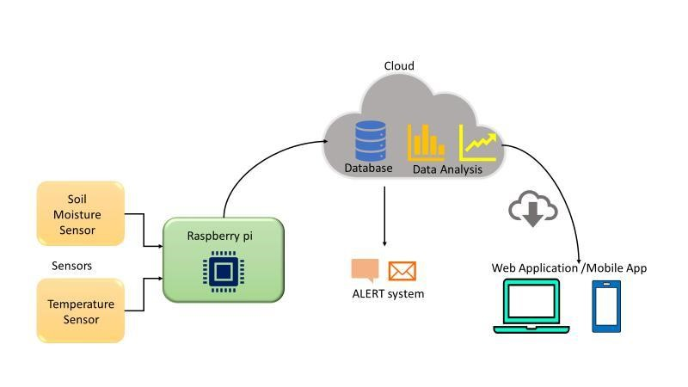

Final Design Architecture of Proposed System

Amazon Web Services – Creating an IoT thing on AWS IoT Core Platform (named Sparkle)

Certificates created for the IoT Thing sparkle are attached to the MQTT Publisher and subscriber code to make the connection secure

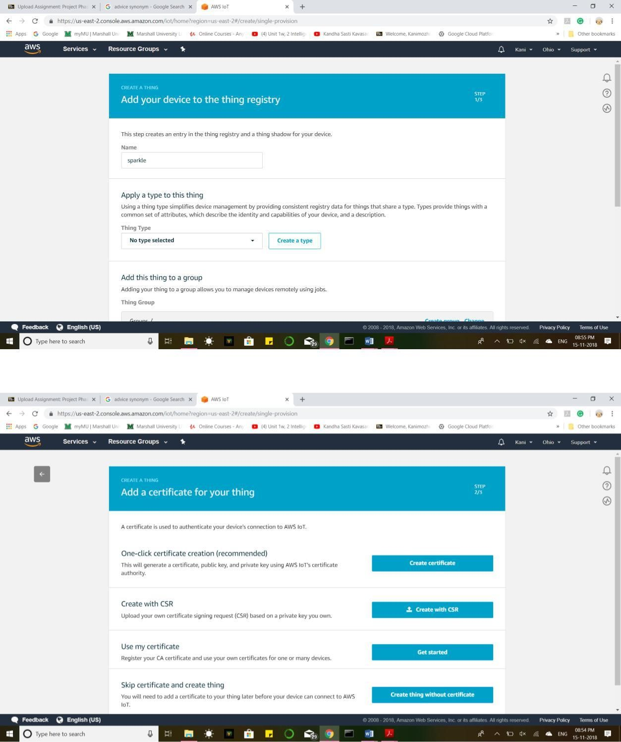

Creating Certificates:

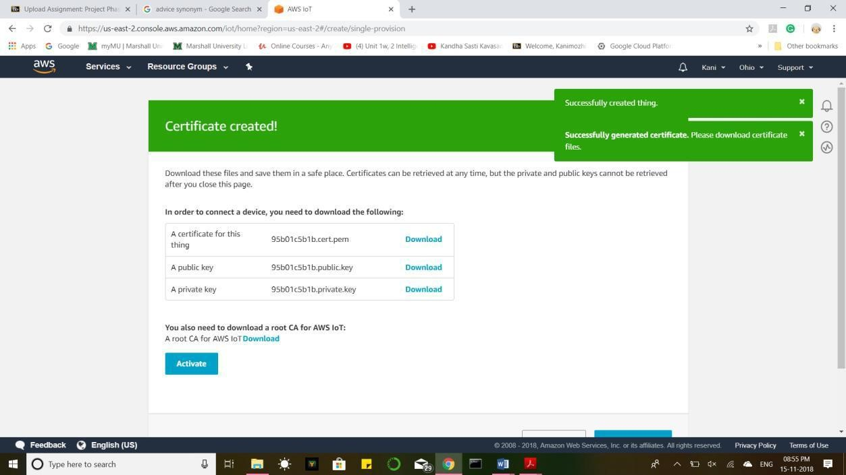

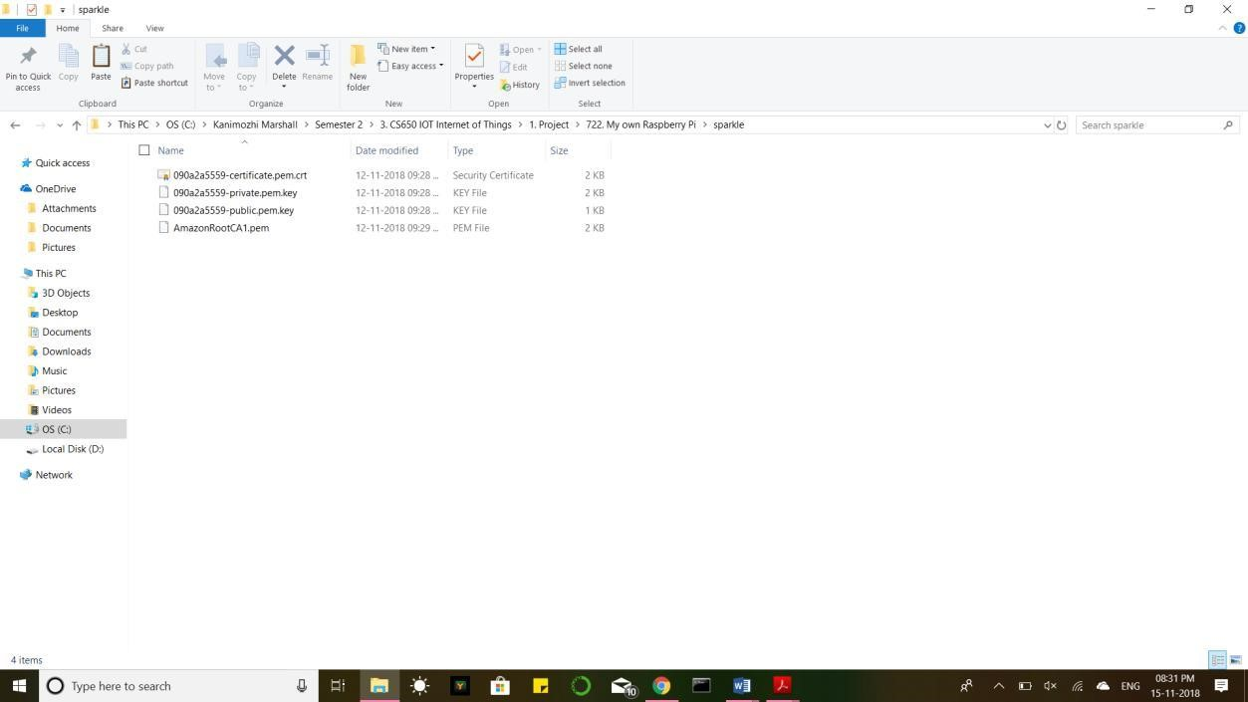

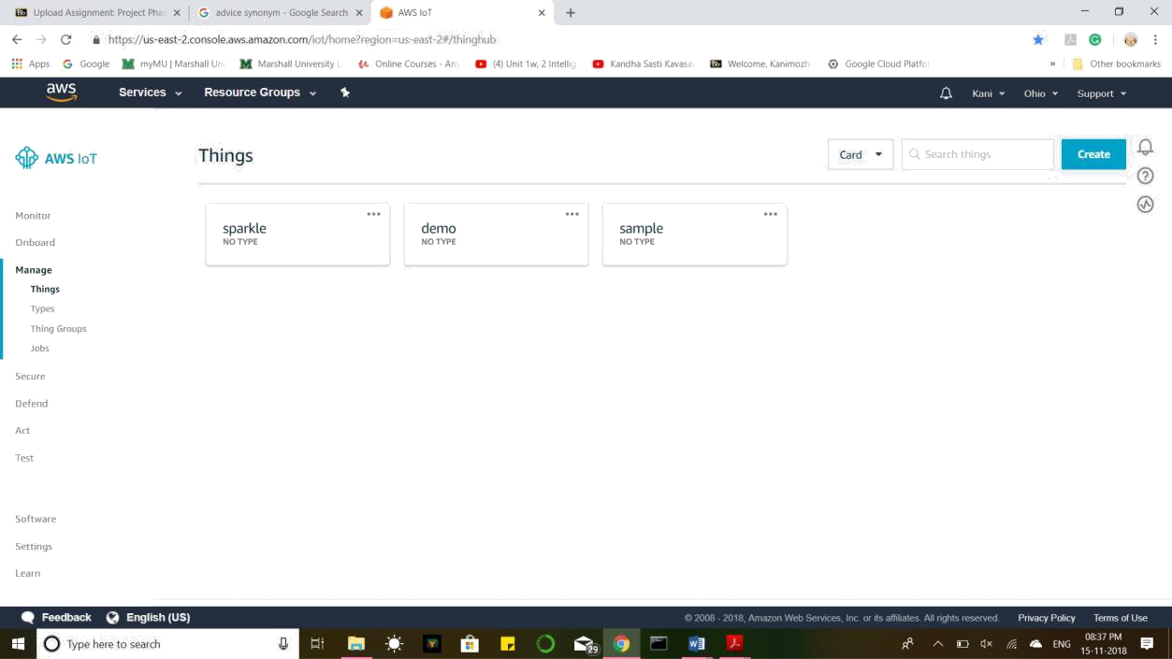

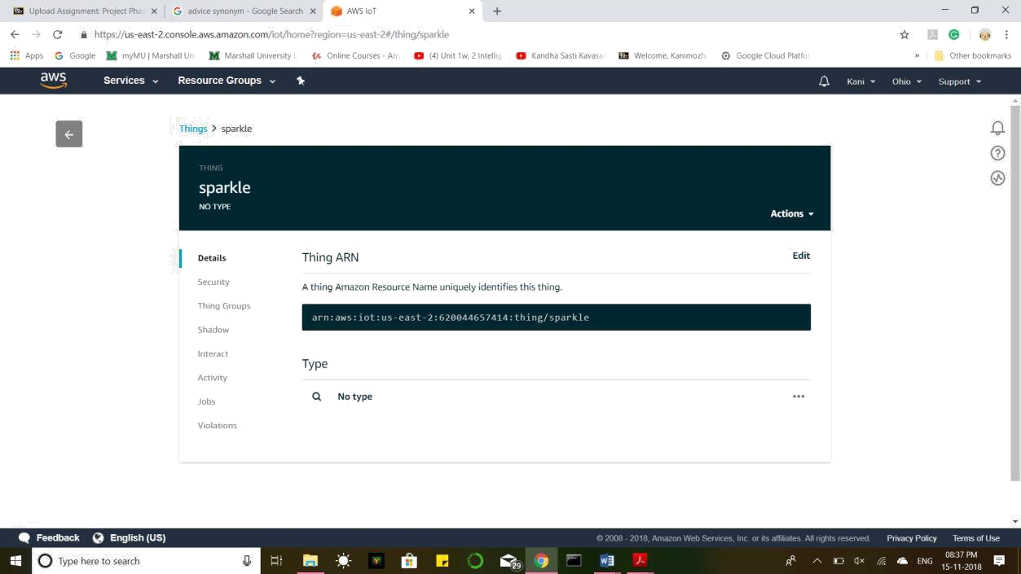

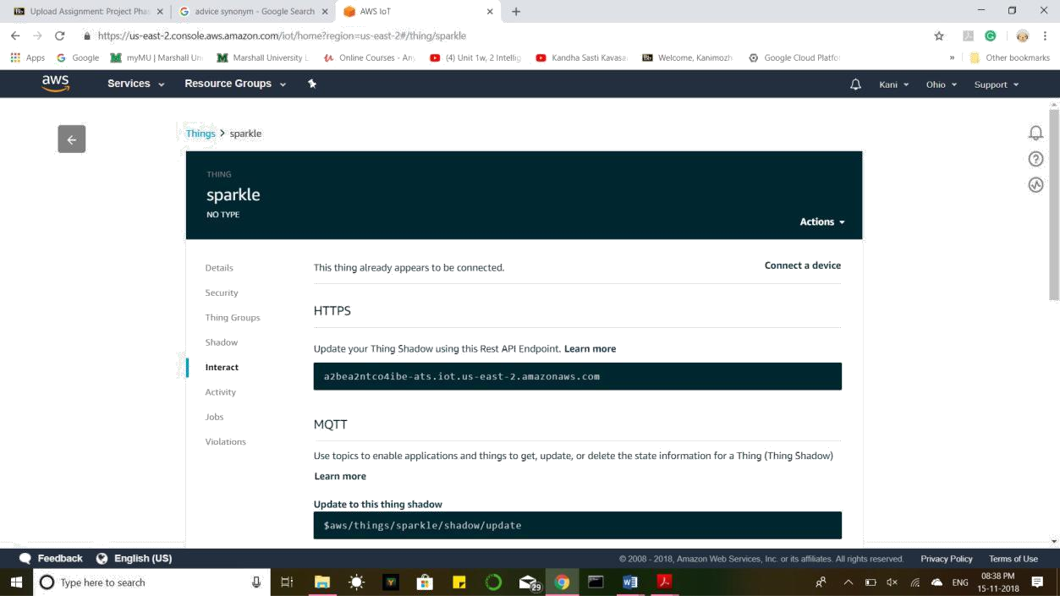

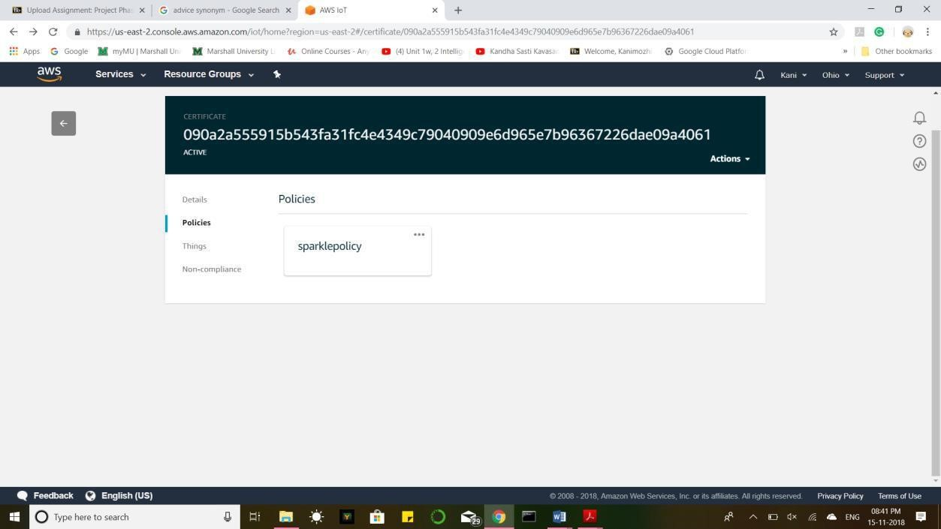

Python Code in Raspberry Pi

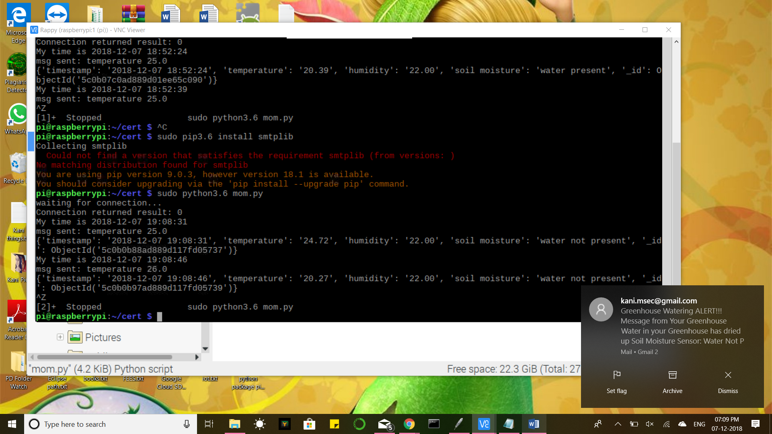

Stored in Database:

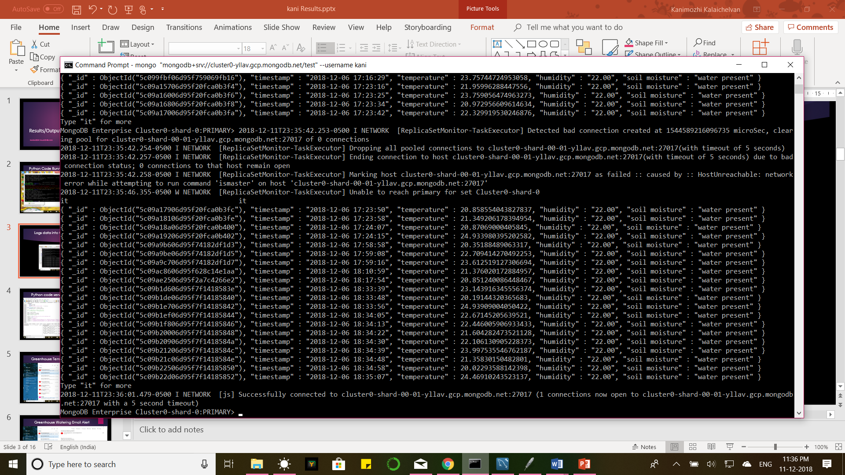

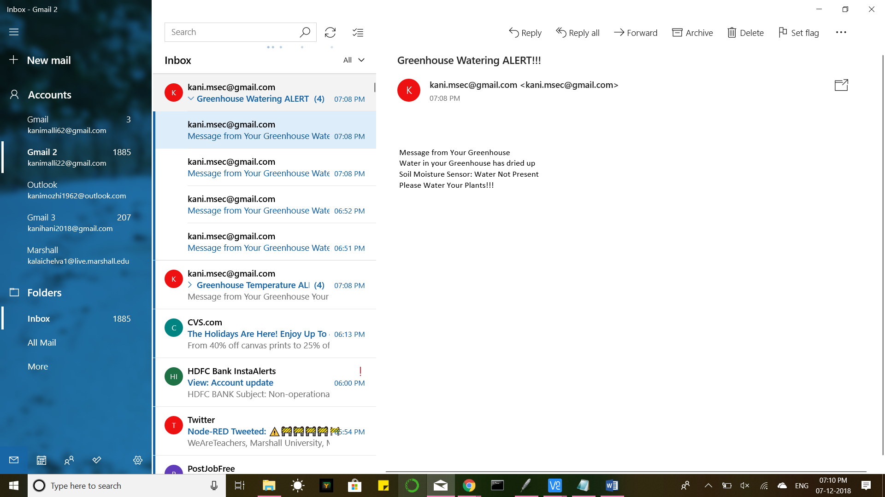

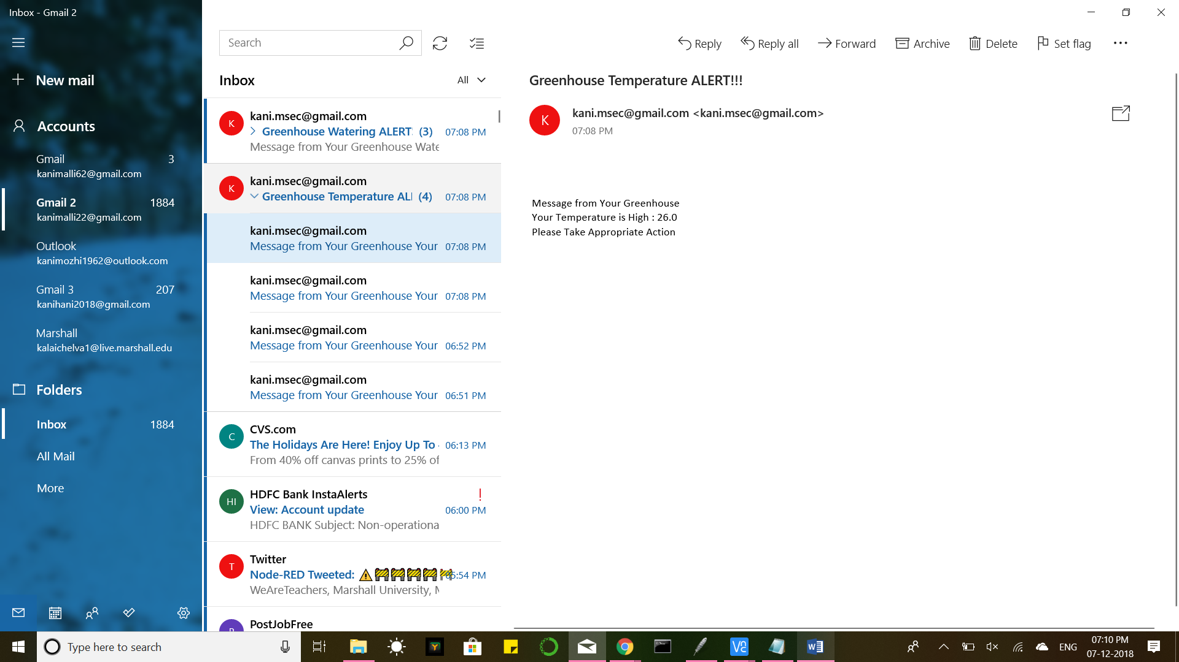

WebApp Deployment

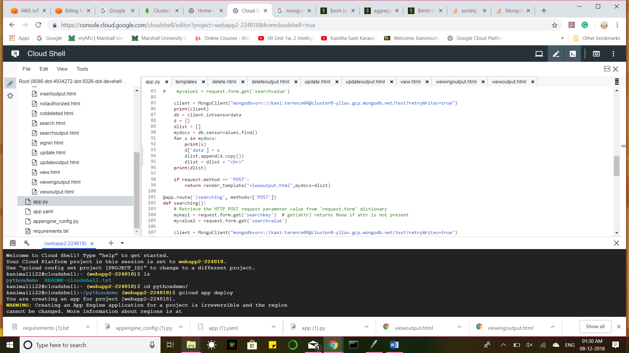

WebApp Login

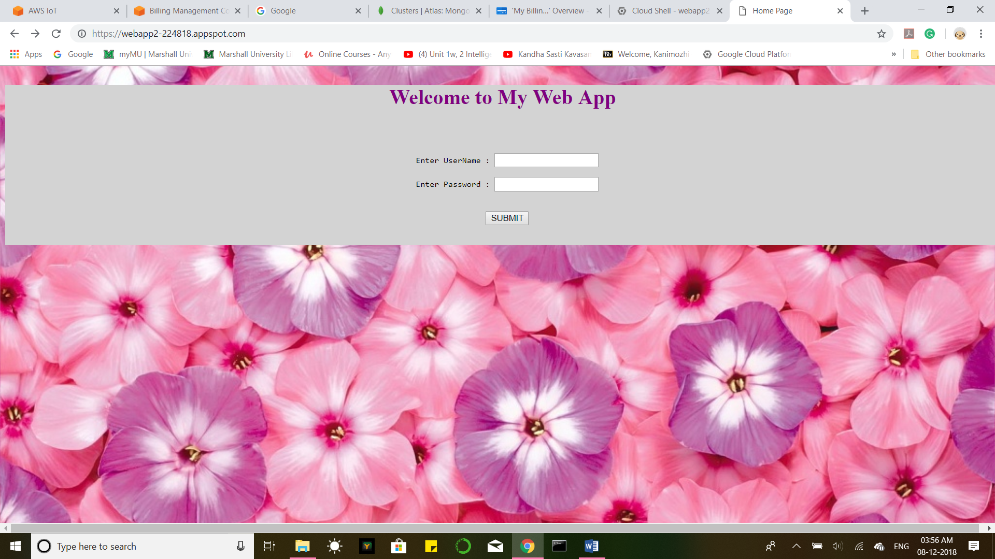

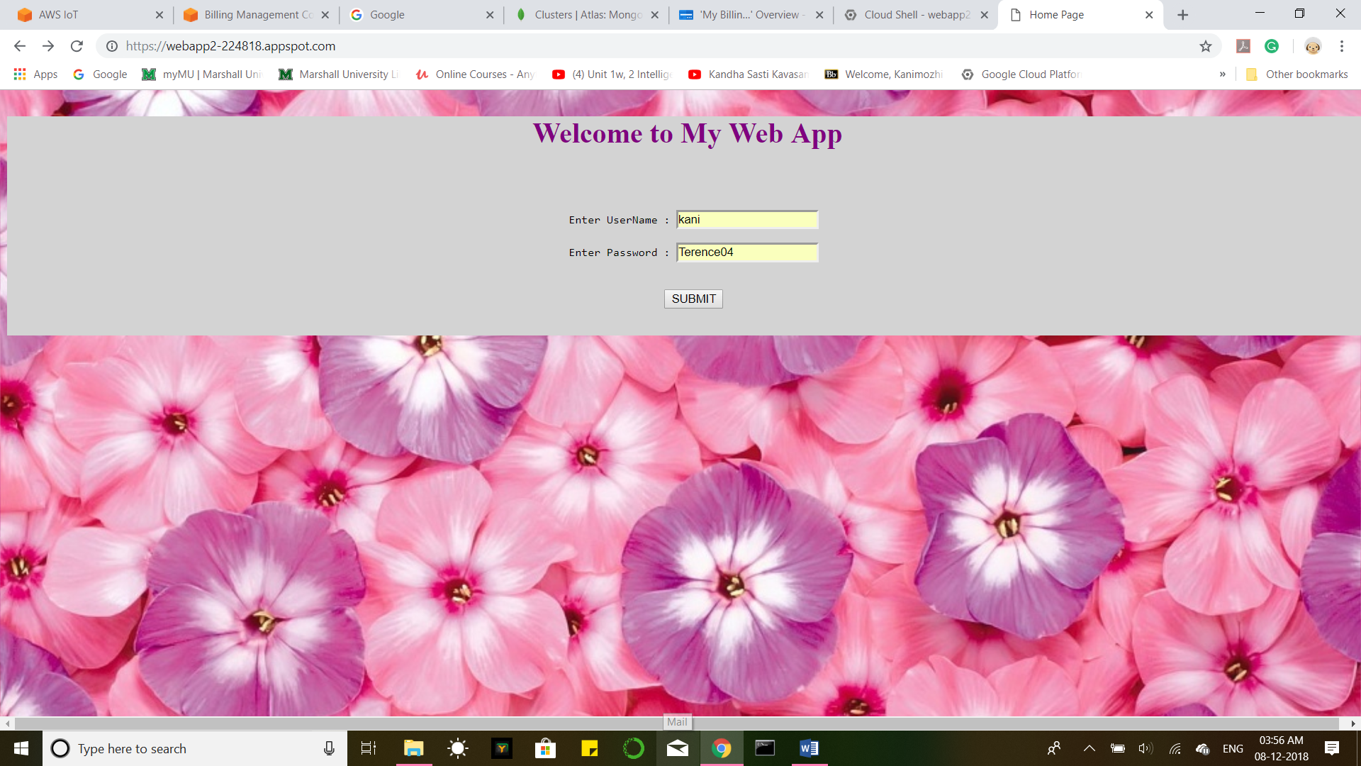

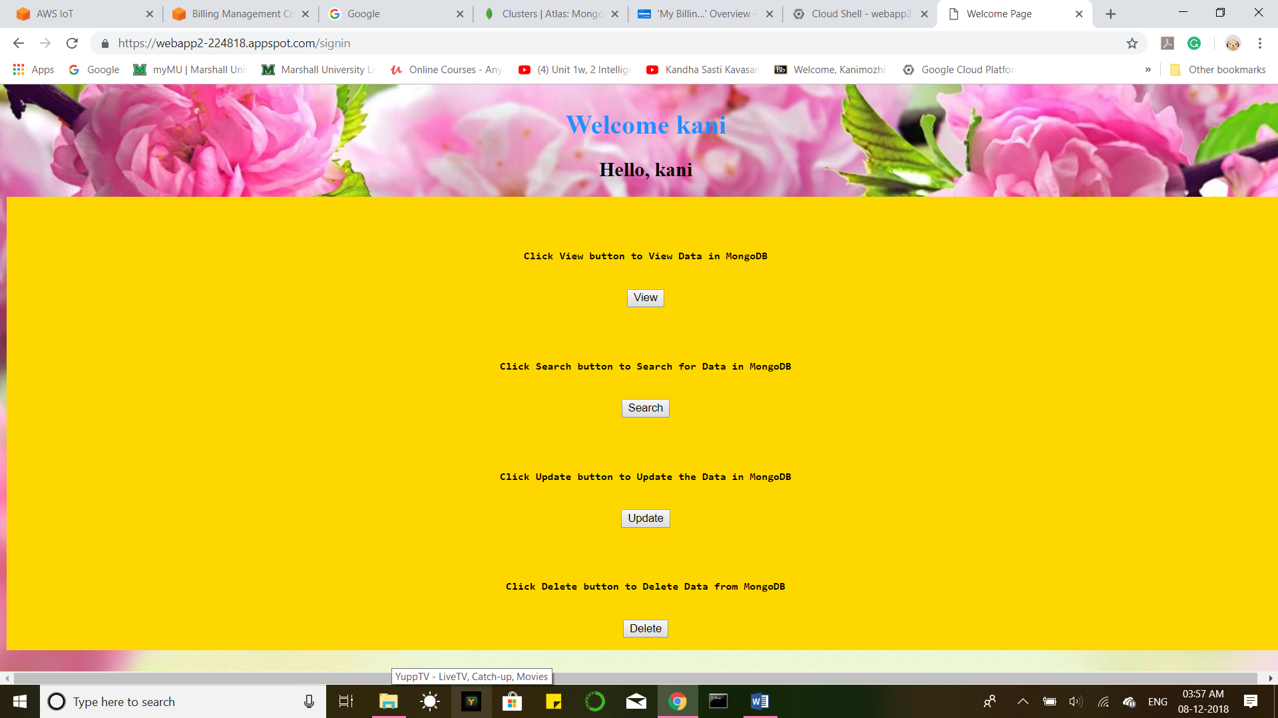

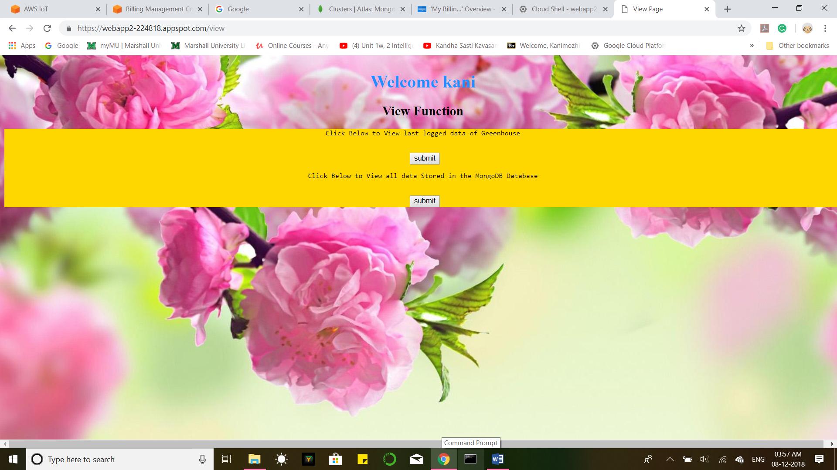

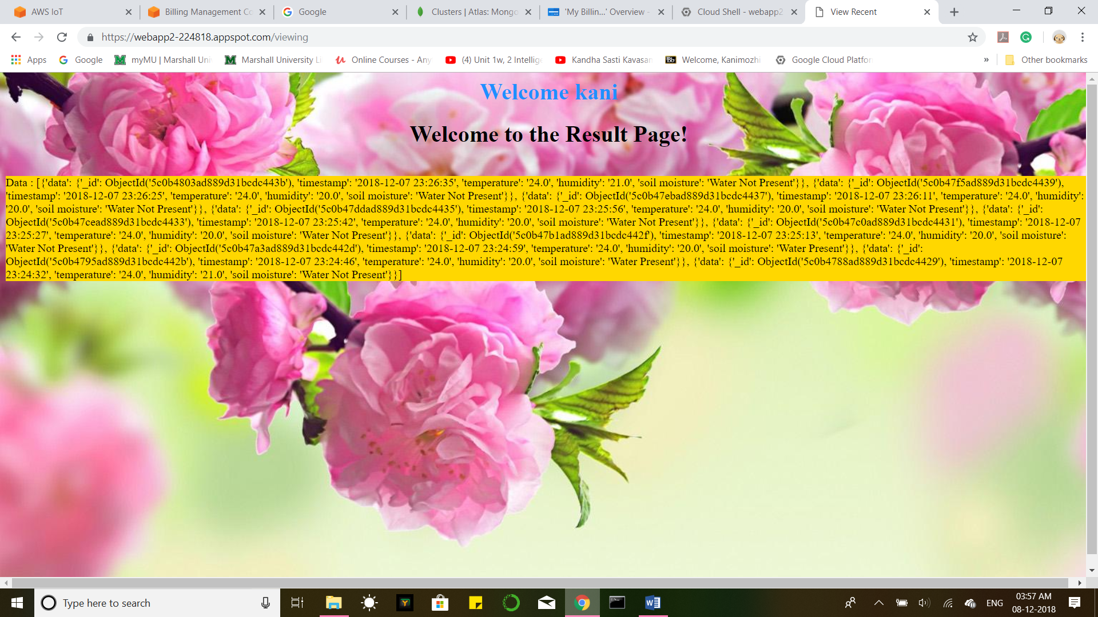

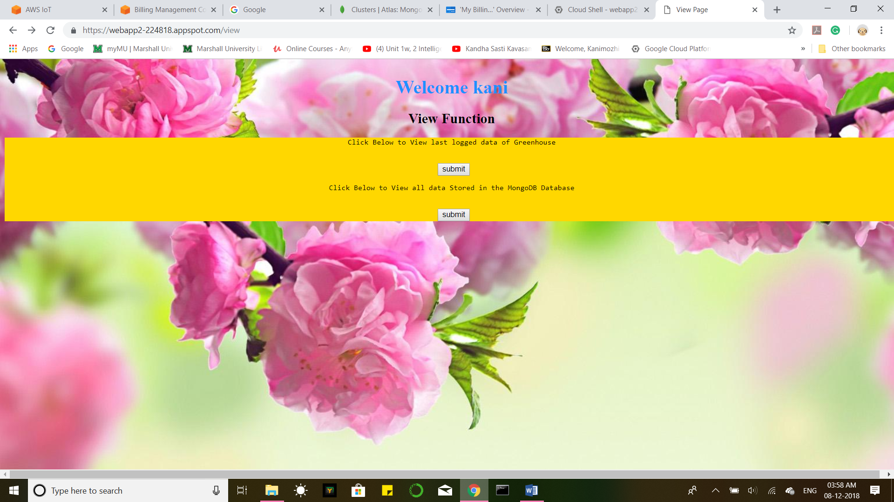

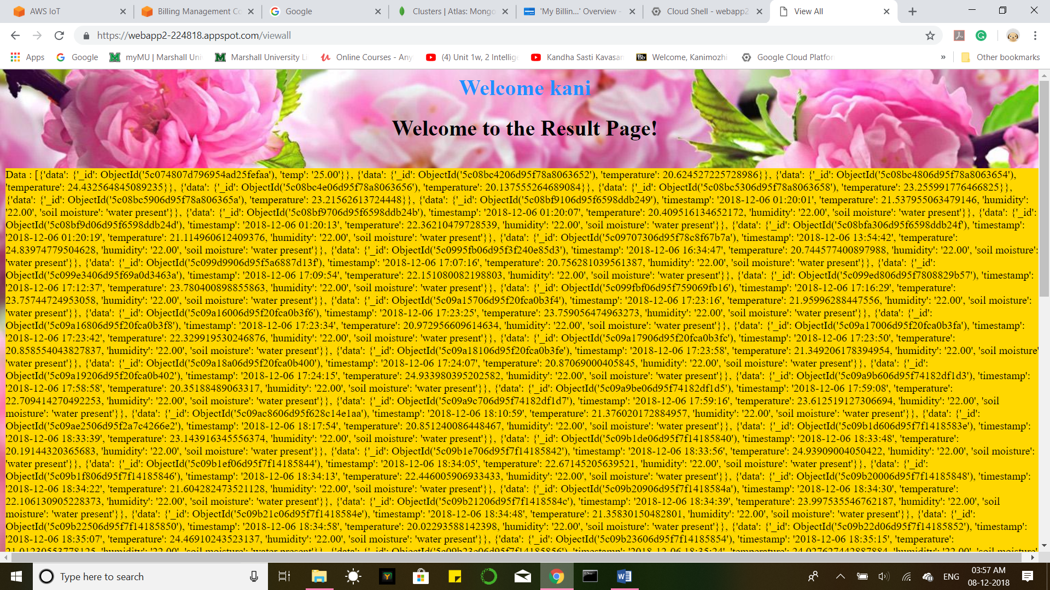

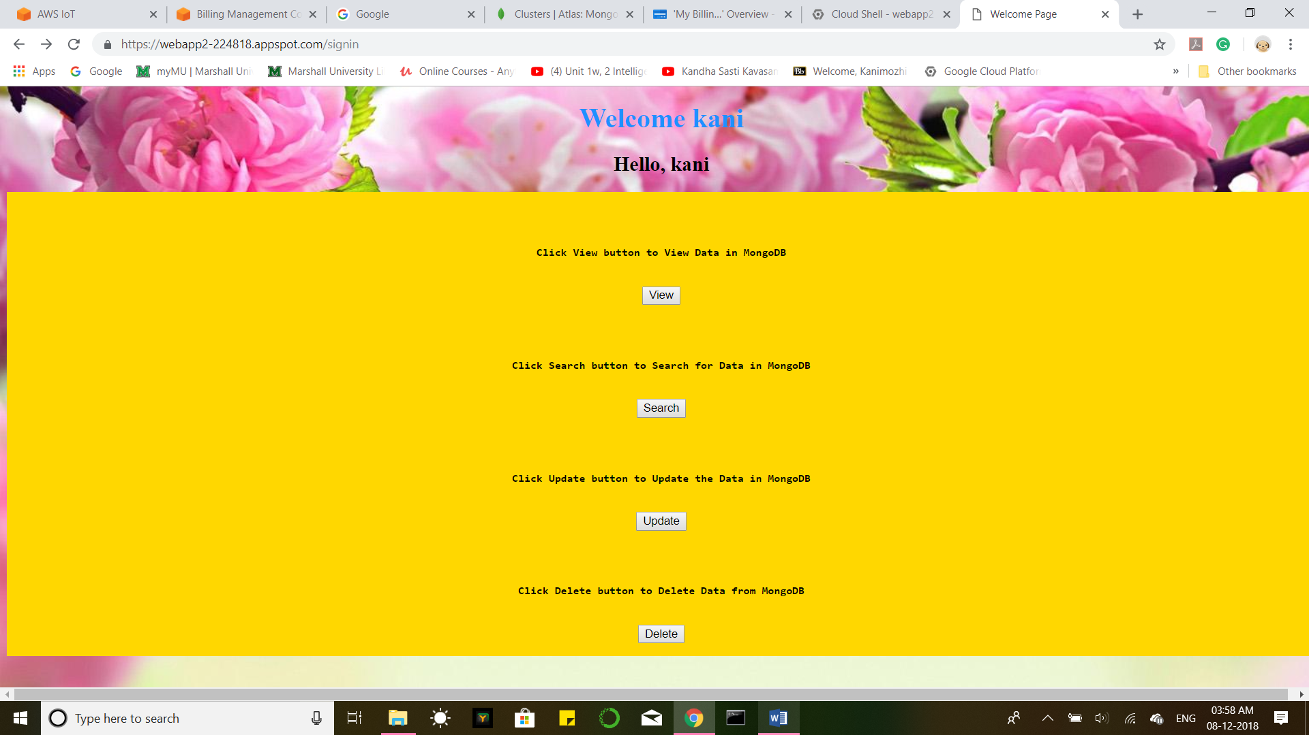

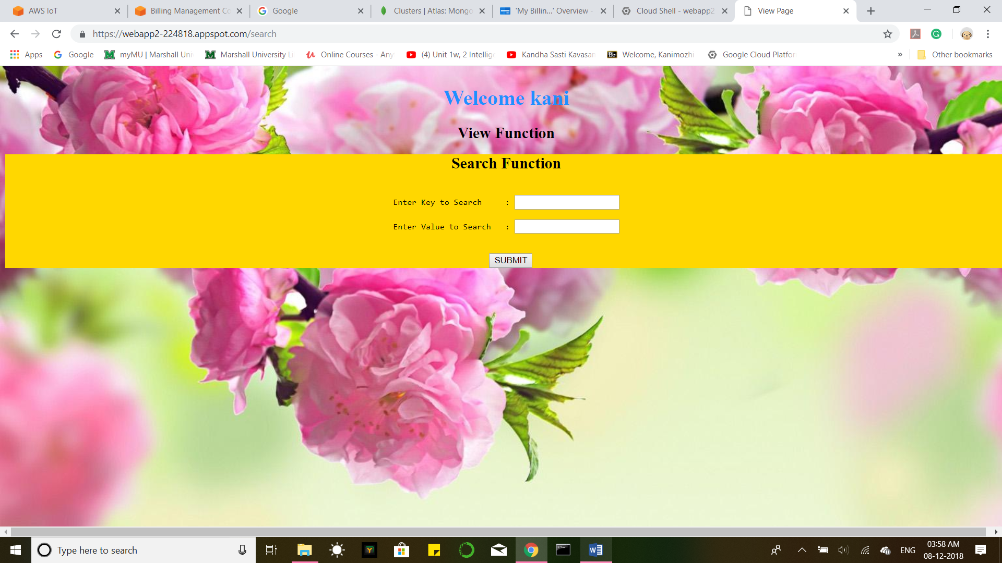

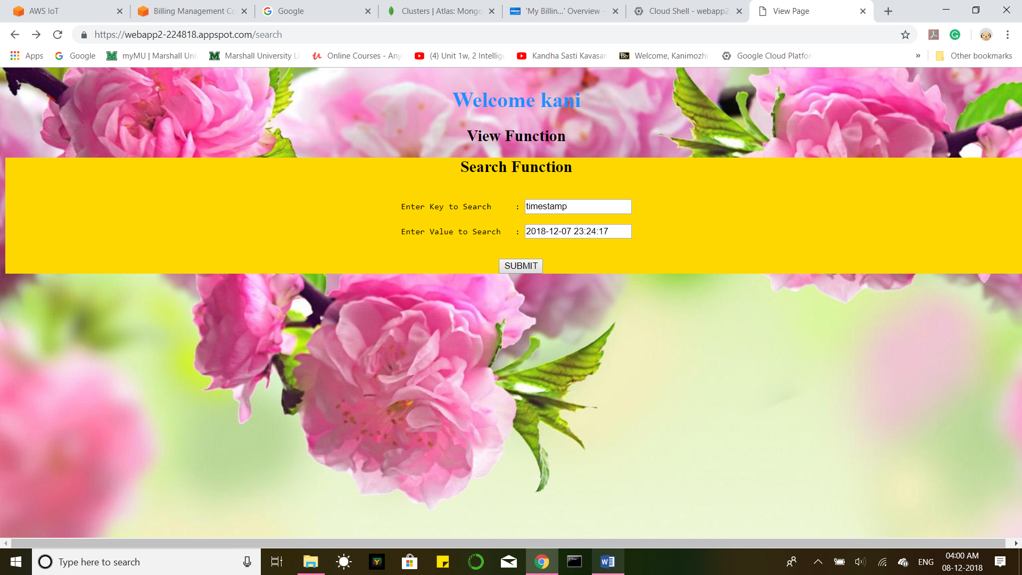

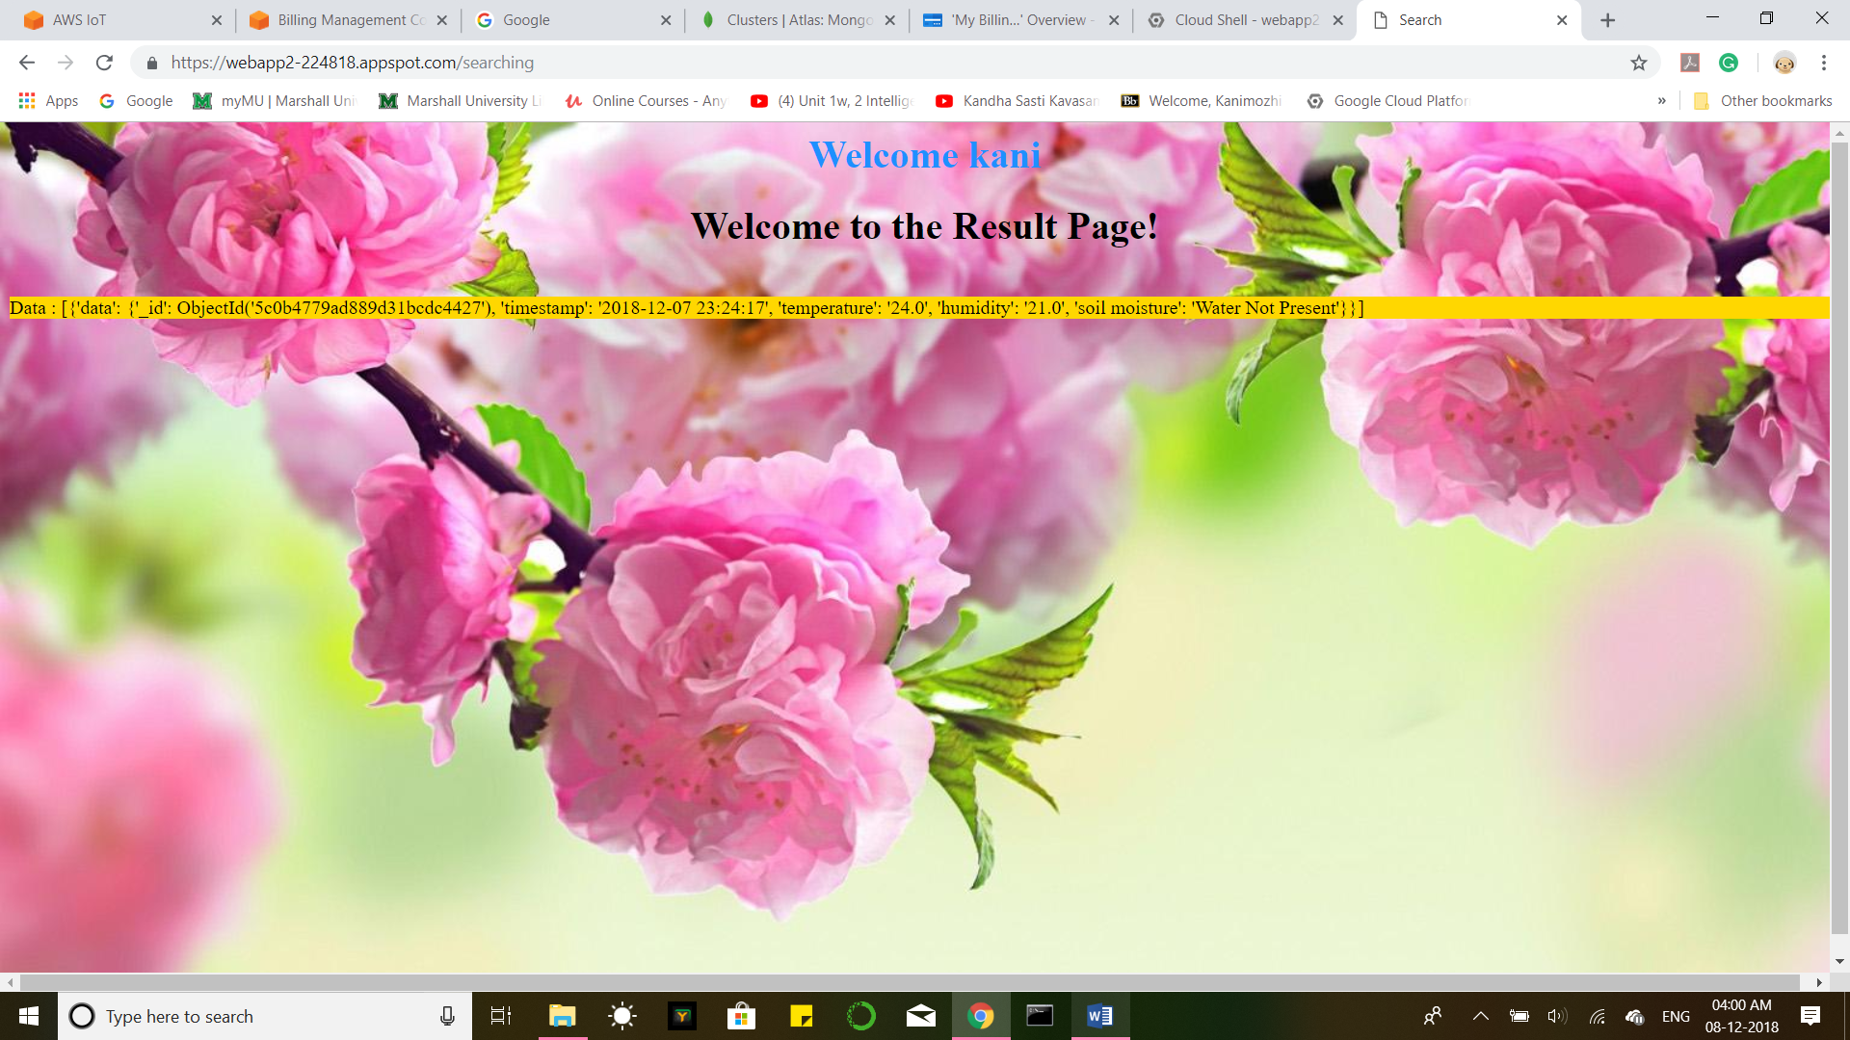

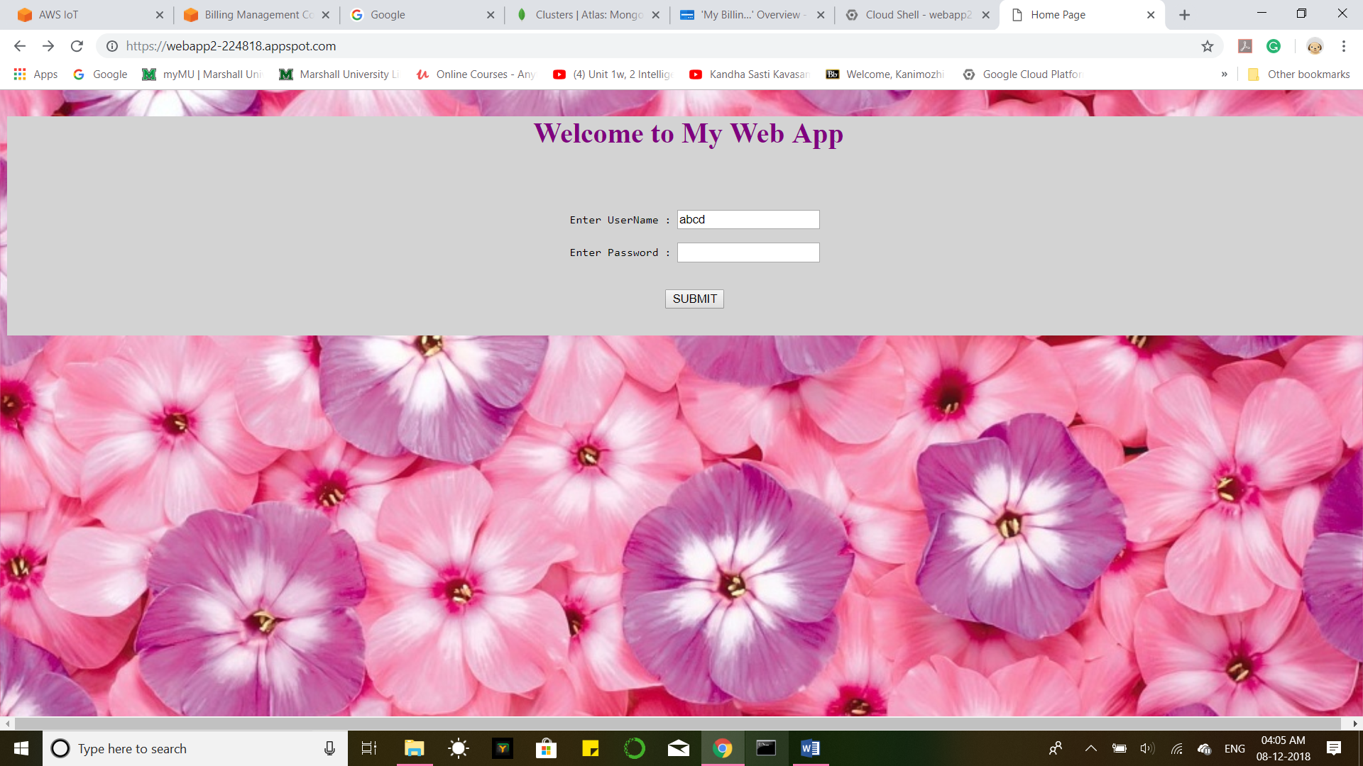

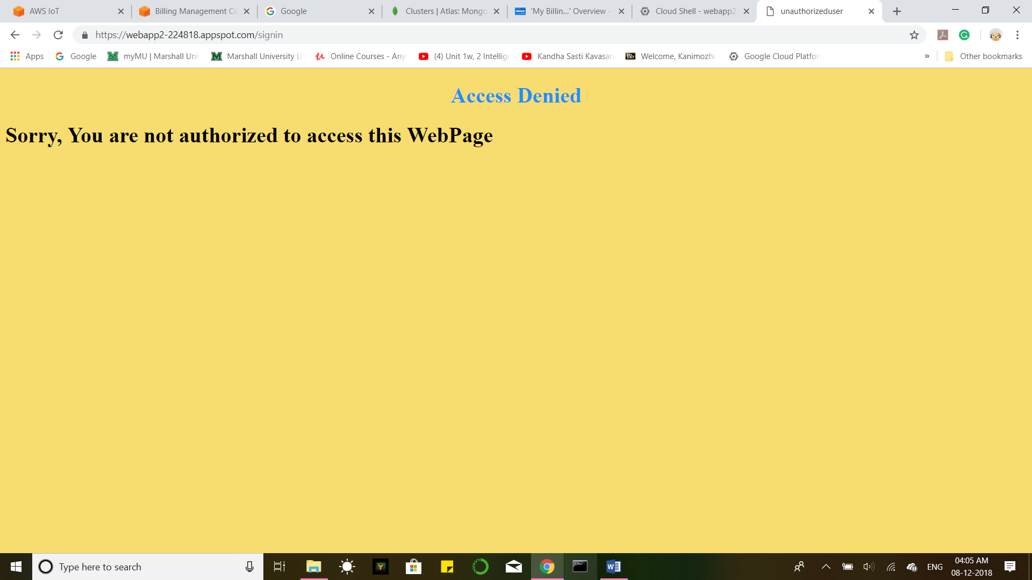

**Conclusion & Future Work:**

The environmental parameters of a greenhouse such as temperature, humidity and soil moisture can be monitored from any location at anytime using a variety of IoT devices. These data stored on the cloud database can serve as the source for future analysis or statistics projects. Our project can be extended by adding actuators to the Raspberry pi (Fan or Cooling System and water sprinkler) which can be controlled from the web application to take the appropriate action. For example, once the user receives an email alert the soil being dry, they can activate the water sprinkler. Greenhouse monitoring serves useful to monitor plants in places with extreme weather conditions . They can be monitored and controlled from remote locations. This project can serve useful in increasing productivity of crops.

# THANK YOU